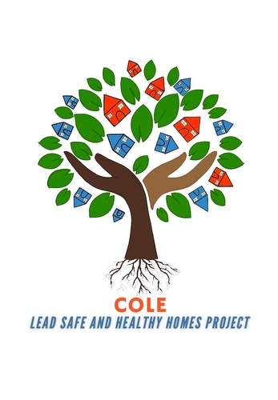Cooking With Cole
Location: 1720 W Locust St. Milwaukee, WI 53206
When: May 11th 3pm
May 25th 3pm
June 8th 3pm
June 22nd 3pm
July 6th 3pm
July 20th 3pm

FREE GROCERIES, LEAD EDUCATION, LEAD SAFE KITS, DIAPERS, WIIPES, RECEIPES, GAME AND PRIZES.
ANY QUESTION CONTACT SHY AT 262-420-3799 OR VISIT OR WEBSITE AT COALITIONONLEADEMERGENCY.ORG

