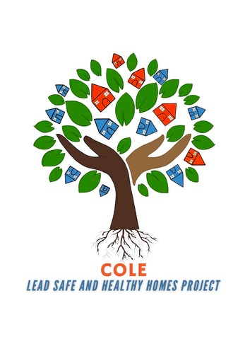Cooking With Cole
Location: 1720 W Locust St. Milwaukee, WI 53206
When: March 17th 5pm
March 31st 5pm
April 21st 3pm (Also Town Hall MTG)
May 12th 5pm
May 26th 5pm

FREE GROCERIES, LEAD EDUCATION, LEAD SAFE KITS, DIAPERS, WIIPES, RECEIPES, GAME AND PRIZES.
ANY QUESTION CONTACT SHY AT 262-420-3799 OR VISIT OR WEBSITE AT COALITIONONLEADEMERGENCY.ORG

